**Task10-ChatGPT**

**CSS Box Model**

The CSS box model is a fundamental concept that describes how the layout of elements is structured on a web page. Every element is represented as a rectangular box that consists of four components: **content**, **padding**, **border**, and **margin**.

**Components of the Box Model**

1. **Content**: The innermost area where text, images, or other elements are displayed. It is defined by the width and height properties.
2. **Padding**: The space between the content and the border. Padding adds extra space inside the element. It can be set individually for each side (top, right, bottom, left) or collectively. It is transparent.
3. **Border**: A line that surrounds the padding (if any) and content. Borders can be styled in various ways (solid, dashed, dotted) and can have different widths and colors.
4. **Margin**: The outermost area, which creates space between the element and other elements. Margins are transparent and can also be set individually for each side.

**Example HTML Layout Using the Box Model**

Here's an example of an HTML document that demonstrates the box model:

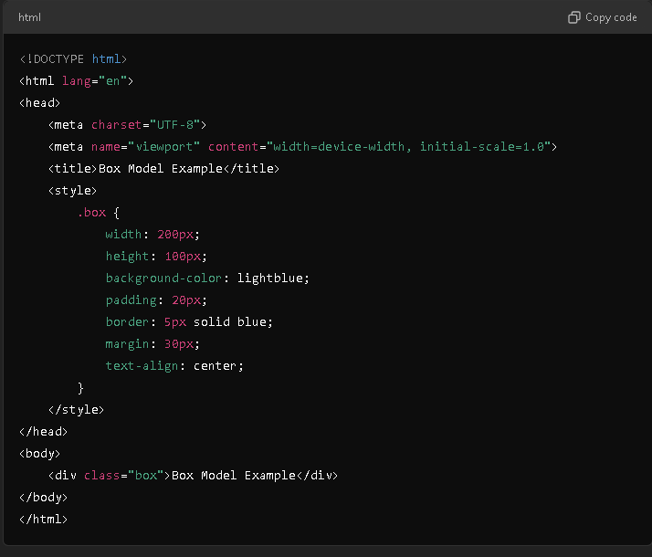

**Result:**

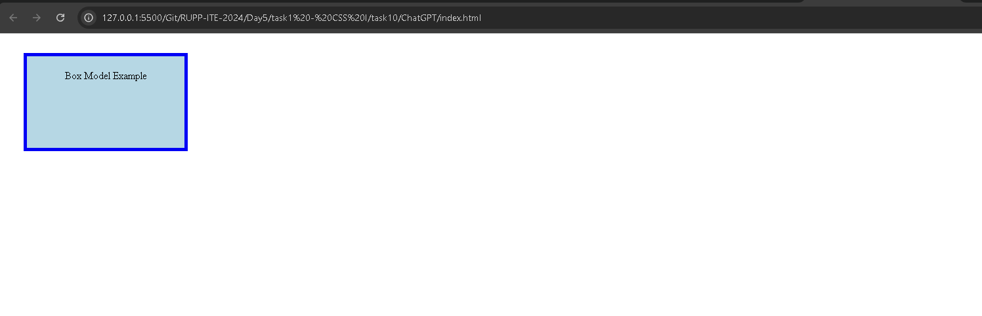

### Visual Explanation

* **Original Layout**: The box has a total width of 250 pixels (content width + padding + border) and a height of 100 pixels. The margin adds additional space outside the border.

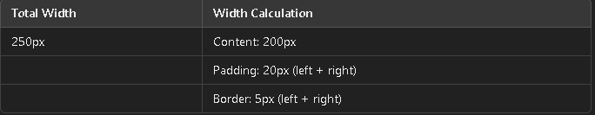

### Changing Padding, Margin, and Border

To see how changing padding, margin, and border affects the layout, we can modify the CSS properties:

* **Increasing Padding**:

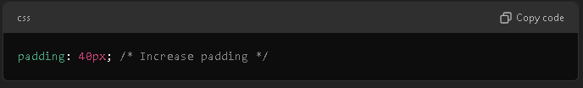

* **Effect**: The content area becomes larger, pushing the text further away from the border.

• **Increasing Margin**:

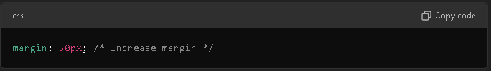

* **Effect**: The space between this box and other elements increases, moving the box further away from surrounding content.

• **Changing Border**:

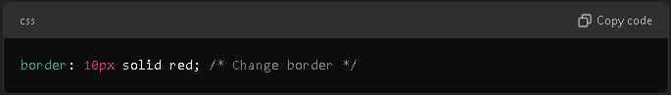

* + **Effect**: The border thickness increases, making the box appear larger while the content area remains the same.

### Example of Modified CSS

Here's how the CSS looks with these changes:

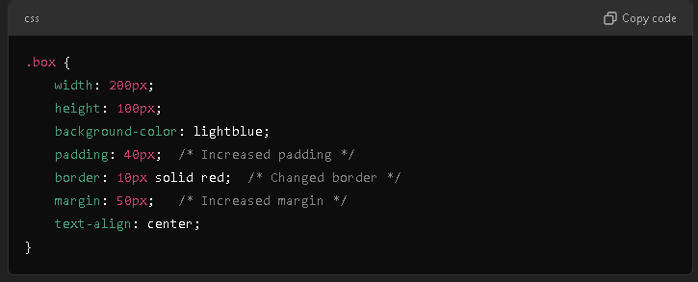

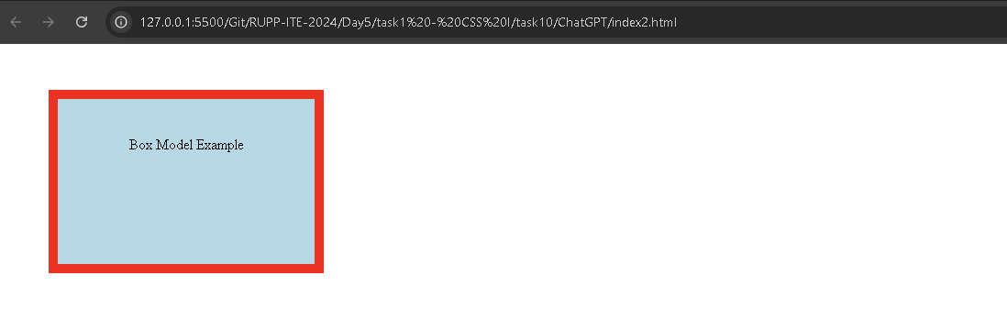

### Summary

The CSS box model is essential for understanding how to create layouts and control spacing in web design. By adjusting padding, margin, and border, you can significantly impact the appearance and spacing of elements on your web page. Experimenting with these properties will help you achieve the desired layout and design.